**Assignment 2**

**ATRIJ ROY, JU IT UG2 A3, ROLL:- 002311001086**

1. Display the Name, manager Id, and hire date of all employees who are either clerk or works in dept 20. the date should be in the following format:

DATE_HIRED

Seventeenth December, 1980

Second April, 1981

SELECT ENAME, MGR AS MANAGER_ID, TO_CHAR(HIREDATE,INITCAP('FMDDSPTH MONTH, YYYY')) AS DATE_HIRED FROM EMP WHERE JOB='CLERK' OR DEPTNO=20;

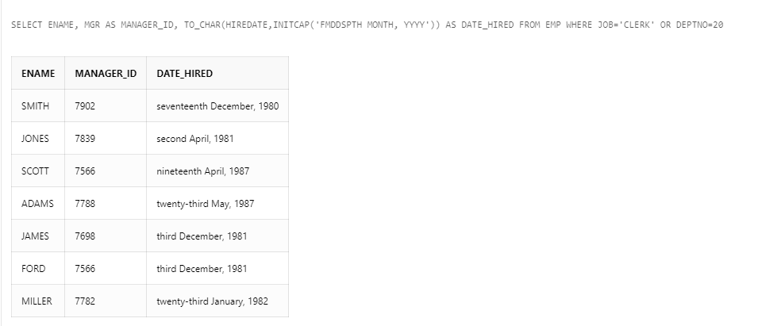

2. List the employee name and old salary and new increased salary by 25% and expressed as a whole number.

SELECT ENAME,SAL AS OLDSALARY, ROUND(1.25*SAL) AS NEWSALARY FROM EMP;

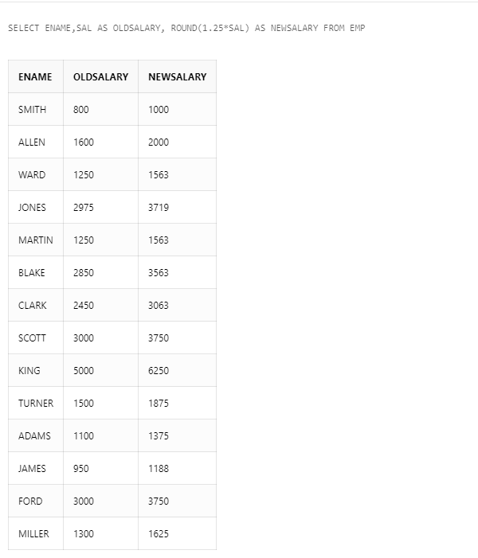

3. List the employee name and salary where name is displayed as left justified and salary with right justified.

SELECT RPAD(ENAME,20,' ') AS NAME, LPAD(SAL,20,' ') AS SAL FROM EMP;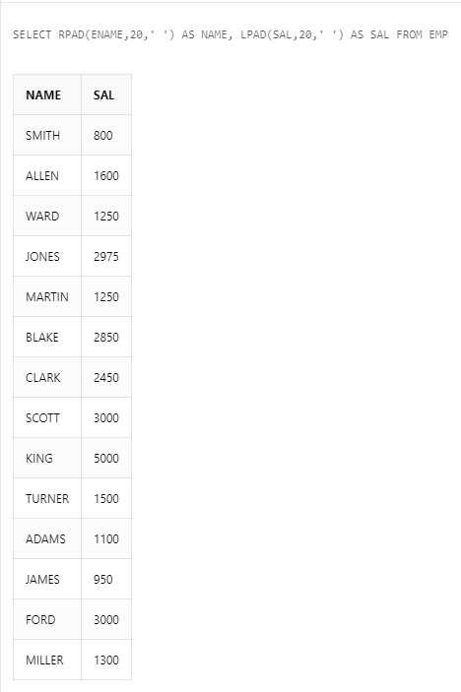

4. Produce the output as follows(for all employees)

ROLE OF THE EMPLOYEE

Name1 (<Job of Name 1>)

Name2 (<Job of Name 2>)

........

Note: Only first character of Name and job will be in uppercase.

SELECT CONCAT(CONCAT(INITCAP(ENAME),'('),CONCAT(INITCAP(JOB),')')) AS ROLE_OF_THE_EMPLOYEE FROM EMP

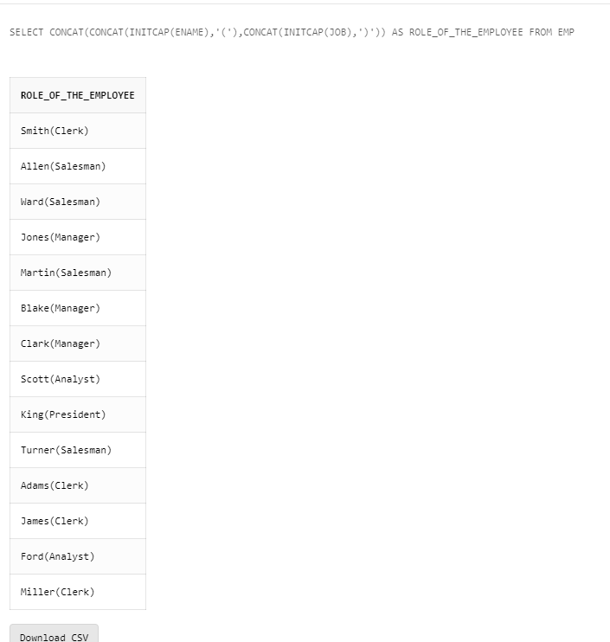

5. Give the details of an employees with job is clerk (enter the job value clerk as input).

SELECT * FROM EMP WHERE JOB='CLERK';

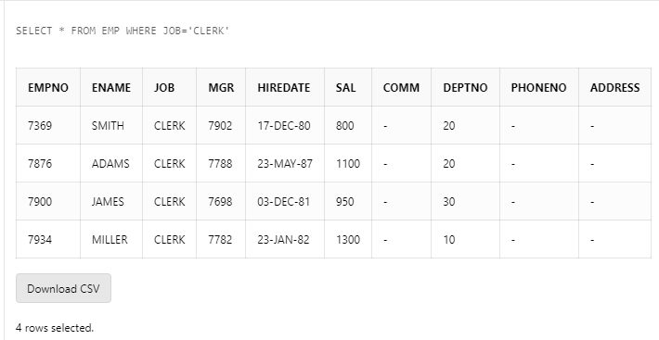

6. Display each employee name with hiredate and salary review date. Assume that date is one year after hiredate. Order the output in ascending review date order.

SELECT ENAME, HIREDATE,HIREDATE+365 AS REVIEW_DATE FROM EMP ORDER BY REVIEW_DATE ASC;

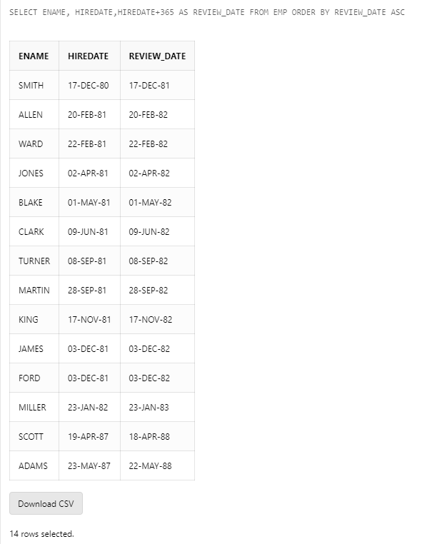

7. Find the employees(s) who earn the highest salary in each job type sort in descending salary order(Use IN operator and subqueries)

SELECT * FROM EMP WHERE SAL IN (SELECT MAX(SAL) FROM EMP GROUP BY JOB) ORDER BY SAL DESC;

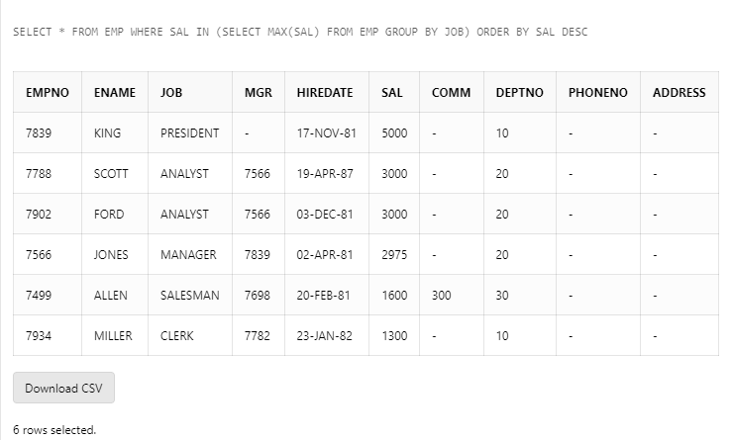

8. Find the most recently hired employee in each department (give number only).

SELECT EMPNO FROM EMP E WHERE HIREDATE IN(SELECT MAX(HIREDATE) FROM EMP WHERE E.DEPTNO=DEPTNO GROUP BY DEPTNO);

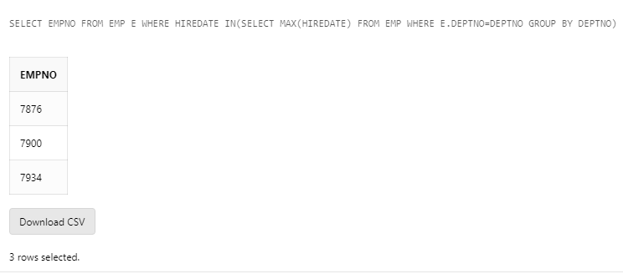

9. Show the name of the department and no of employees who works in that department. Sort in department number.

SELECT D.DNAME, COUNT(E.EMPNO) FROM EMP E, DEPT D WHERE E.DEPTNO = D.DEPTNO GROUP BY D.DNAME, D.DEPTNO ORDER BY D.DEPTNO;

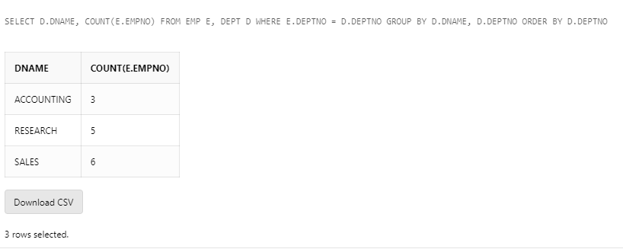

10. Display the Id, name, salary and the salary grade for any employee who earns the maximum salary for their department. Sort in department number.

SELECT E.EMPNO, E.ENAME, E.SAL, S.GRADE FROM EMP E, SALGRADE S WHERE E.SAL IN(SELECT MAX(SAL) FROM EMP GROUP BY DEPTNO) AND E.SAL BETWEEN S.LOSAL AND S.HISAL;

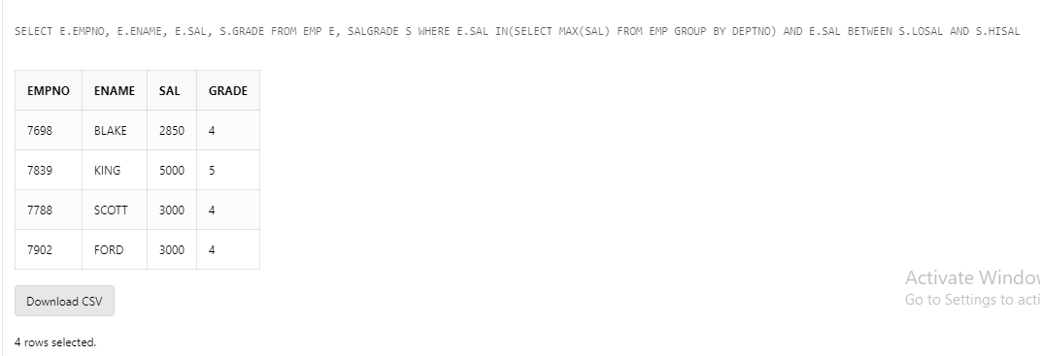

11. In which year did most people join the company? Display the year and number of employees.

SELECT TO_CHAR(HIREDATE, 'YYYY') AS YEAR, COUNT(EMPNO) AS NO_OF_EMPLOYEES FROM EMP GROUP BY TO_CHAR(HIREDATE, 'YYYY') HAVING COUNT(EMPNO)=(SELECT MAX(COUNT(EMPNO)) FROM EMP GROUP BY TO_CHAR(HIREDATE, 'YYYY'));

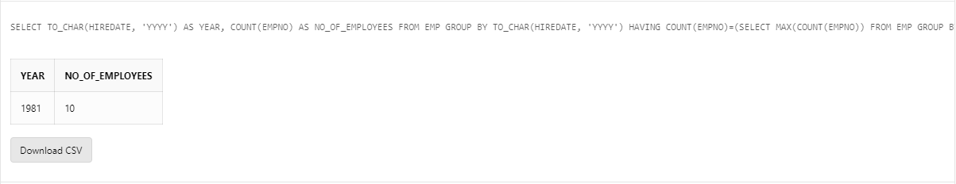

12. Show the every alternate row in employee table.

SELECT EMPNO, ENAME, JOB, MGR, HIREDATE,SAL, COMM, DEPTNO, PHONENO, ADDRESS FROM(SELECT EMPNO, ENAME,JOB, MGR, HIREDATE, SAL, COMM, DEPTNO, PHONENO, ADDRESS, ROWNUM RN FROM EMP) WHERE MOD(RN,2)=1;

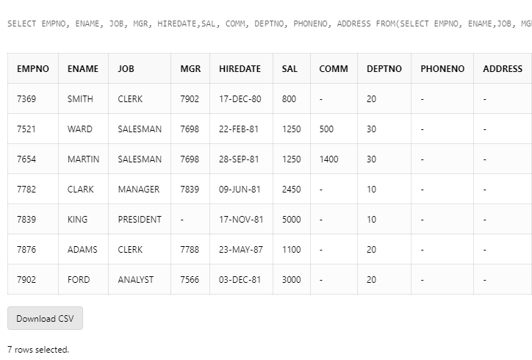

13. Display the total salary of all employees. Total salary = salary + commission.

SELECT EMPNO,ENAME, SAL+NVL(COMM,0) AS TOTAL_SALARY FROM EMP;

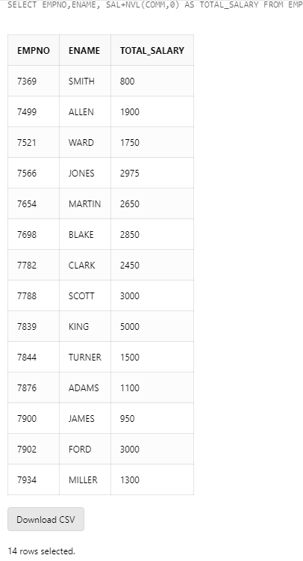

14. Display the department name and available jobs in that department.

SELECT DISTINCT D.DNAME AS DEPARTMENT, E.JOB AS AVAILABLE_JOBS FROM EMP E, DEPT D WHERE D.DEPTNO = E.DEPTNO ORDER BY DNAME;

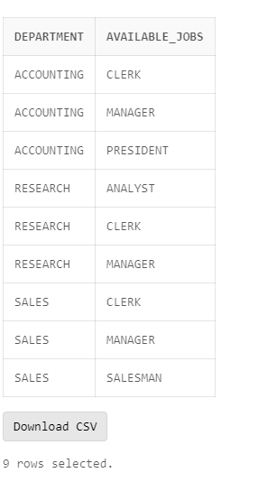

15. Display all the available departments and the employee(s) works under it.

SELECT D.DNAME, LISTAGG(E.ENAME,',') WITHIN GROUP (ORDER BY E.ENAME) AS EMPLOYEES FROM (SELECT DISTINCT ENAME, DEPTNO FROM EMP) E JOIN DEPT D ON D.DEPTNO= E.DEPTNO GROUP BY D.DNAME ORDER BY D.DNAME;

